Safety Advisory Group - Emergency Plan Guidance
Status - Public
Contents
1 Emergency Plan Guidance 9
1.1 Introduction 9
1.2 What is an Emergency Plan? 9
2 Emergency Plan Considerations 10
2.1 Event Control 10
2.2 Command & Control 11
2.3 Roles & Responsibilities 11
2.4 Crowd Control 11
2.5 Communication System 12
2.6 Media Communications 13
2.7 Evacuations 14
2.8 Show-stop 14
2.9 Welfare of Vulnerable People & Children 15
2.10 Adverse Weather Plans 15
2.11 Terrorism (bomb/suspicious package/ run, hide, tell) 15
2.12 Emergency Services 16
2.13 Action Cards 17
2.14 Site map 17
2.15 Emergency Plan Awareness & Training 17
3 Risk Assessment 18
4 Further reading 18
5 Appendix A - Specific Guidance for events within the detailed emergency planning zone for the Atomic Weapons Establishment (AWE) 7
5.1 Atomic Weapons Establishment guidance 7
5.2 What is the Atomic Weapon Establishments? 7
5.3 What is the Detailed Emergency Planning Zone? 7
5.4 What could happen at Atomic Weapons Establishment? 7
5.5 Hazards from an AWE radiation emergency 8
5.6 What plans do I need for my event? 8
6 What your event emergency plans need to consider 9
6.1 Activation 9
6.2 Immediate protective action to take 10
6.3 Evacuation 11
6.4 Food and drink 11
6.5 Further information for Atomic Weapons Establishment 12
7 Appendix B – METHANE Form 13

Emergency Plan Guidance

Introduction
Holding an event can be rewarding providing everything goes according to plan. However, when things don’t go to plan there can be a number of consequences. There are a number of well-known incidents that have occurred at a variety of events from sports events to festivals such as Hillsborough (1989) and the Manchester Arena Attack (2017). Incidents can be unpredictable and variable, from a horse bolting through a crowd to a stall catching fire or unreasonable weather causing casualties of heat exhaustion or cold exposure.
As an Event Organiser, you have a responsibility for those attending and have a duty to plan, manage and monitor your event to ensure safety for both staff and public. You are likely to have considered contingencies if something were to go wrong throughout the planning process. If you don’t have an emergency plan and something goes wrong, then there is the potential of a bad situation escalating. Although the likeliness of an emergency or incident may be low, an emergency plan is a fundamental part of your event plan. This guidance provides numerous considerations to assist you in preparing plans as a responsible Event Organiser.

What is an Emergency Plan?
An emergency plan is a formal plan that should be established to deal with any incident that may arise e.g., a fire, evacuation of the site, adverse weather, overcrowding, and threats such as terrorism. The complexity of an emergency will depend upon the size and nature of the event itself. A simple, clear and comprehensive plan may be acceptable for a small event (eg. village fetes and street parties).
The plan should clearly address a number of factors such as integral coordinating roles and responsibilities in an emergency; communication systems and how the public will be informed and evacuated etc. You will need to consider who will manage the emergency and liaise with the Emergency Services and other services such as Local Authorities should an emergency occur. Please note that events cannot rely on the 999 or emergency services for the running of their event.
To ensure awareness and instil confidence, all those involved in the event must be aware of the Emergency Plan and what to do if there is a need to activate. You may wish to organise a tabletop exercise to test your emergency plan prior to the event and invite members of the Safety Advisory Group (SAG) to attend and advise. It is your responsibility to create an Emergency Plan, the SAG is established to be a point of contact to provide support and advise on risks.

Emergency Plan Considerations
The emergency plan should be detailed and include the various components addressed in this guidance document. Note that plans should not be limited to the considerations outlined in this document due to the wide scope of events that may not require the same level of considerations (eg. village fetes to large multi-day festivals).
This guidance will outline considerations listed below:
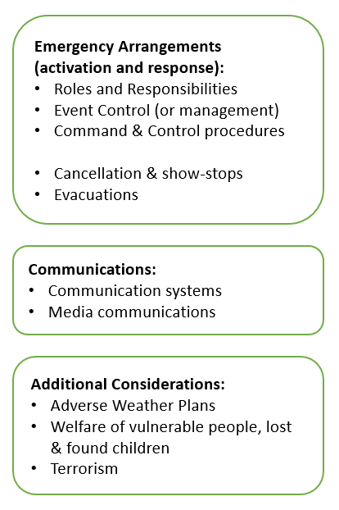

Event Control
Those with a specific duty and responsibility for emergency plans such as an Event Safety Officer require a central location to coordinate and co-locate. It is advised that events (certainly larger events), consider setting up a control room or similar to enable:
- The event to be monitored and assess early indication of any problems.
- Control of any incidents.
- Direct resources to deal with any problems.
- Act as a base for any communications systems.
- Provides a focus point for any public concern.
- Appropriate staffing throughout the event and provided with communication systems.
A location such as Event Control can also act as an area in which emergency resources and equipment can be stored - log books, radios, plans, maps, phones and directory, Wi-Fi capability, photocopiers etc.

Command & Control
Command and control refer to the structure that provides clear command, control and co-ordination arrangements in responding to an incident or emergency. To create an effective command and control, the plan needs to:
- Outline who will has overall responsibility and other individuals that will play a part in the coordination/decision making process (event organiser/site owner etc).
- Where the coordination of the event and emergency response will take place.
- Any liaison staff to work with emergency services if required.

Roles & Responsibilities
Roles and responsibilities should be outlined for all those with an important role to play in activating and supporting the emergency plan. Roles may vary across events but there should be individuals that are appointed to competently assist. An example of a specific role is an Event Safety Officer whose role is to oversee all aspects of Event Safety and to liaise with the Emergency Services.
Additionally, whatever an individual’s role during an event, they should understand what to do in an emergency, for example, how to raise the alarm and understanding location of exits and evacuation areas.

Crowd Control
The type of event and the numbers attending will determine the measures required to ensure safe practices. Consideration will need to be given to the number and positioning of barriers and stewards, including the provision of communication systems to address the public.
When planning for an event, set a realistic maximum number who can attend considering Premise License regulations and factors such as the number a venue/space can hold. Capacity may also be reduced dependent upon the activities being planned. To prevent overcrowding, it may be appropriate to monitor numbers attending and where appropriate, issue numbered tickets or distribute through named contacts. Be prepared for gate crashers and the possibility of forged tickets and importantly, supervise the event to prevent crushing.
Remember that one particular attraction may draw large numbers of visitors and it could be necessary to establish a crowd profile to assist in stewarding and crowd control.

Stewards & Volunteers
Stewards at larger events must be fully briefed on all aspects with written event instructions, site plans and checklists provided to them including crowd control and emergency arrangements.
All stewards should be properly trained and competent, as they will need to be constantly on the lookout for hazards, which could develop during the event. Suitable briefing must be provided for duties such as guiding vehicles, clearing emergency exits, and sorting out any behavioural problems.
Stewards must have appropriate personal protective clothing for the season and daylight hours. It is also important that the public can easily identify stewards if assistance is required. At all day events, duty rotas will be required.
Some smaller events may use volunteers to assist with crowd management. General duties under the Health and Safety at Work Act (1974) need to be considered and ensure volunteers have relevant training and been briefed for the event.
More regarding stewards can be discussed at the SAG with Trading Standards and other appropriate agencies.

Communication System
There must be an effective communications system in place to aid event staff to run the event with the ability to address any safety related issues and enable to prepare/react to an emergency quickly. It is important to note that in an emergency, mobile networks may become busy with calls from the public, therefore a contingency communication method may be required. Consider methods to:
- Provide those with key emergency related roles with a means to communicate including contingency arrangements (e.g., mobile/radio).
- Consider communications with all staff (e.g., radio/PA system), consider code words as outlined in the table below.
- Consider communication methods and Public Address systems for announcements to staff and the public (e.g., PA system/loud hailer/social media).
- Larger events may also require a system with an emergency power backup to ensure continuity of communications.
- For smaller events such as village fetes and street parties, a portable loudhailer may be sufficient.

Emergency Codes
It is important to ensure that there are communication systems and methods to contact staff and the public separately as some incidents may require management of crowds. When communicating with staff about an incident/emergency that may be overheard, emergency codes can be used to manage communications. Codes such as numbers or colours can be used as demonstrated in the table below.

Code Mr Case | Suspect package/bomb threat
Code Red | Fire
Code Zulu | Evacuation required

Media Communications
If an incident or emergency occurs it is possible the local or national media will be interested in reporting the story, it is important to have a plan in place to deal with this exposure. Have plans and spokespeople pre-identified to deal with the media.
Plans can include pre-prepared factual information about your event which can be released immediately if necessary (e.g., type of event, number of years running, no of people attending).

Evacuations
Emergencies can develop very quickly and require prepared and competent staff to manage an incident. The plan needs to outline how you will evacuate people to an area of relative safety so they can continue to a place of absolute safety.
To prepare and ensure the event is equipped to initiate an evacuation, the plan needs to outline the process. Emergency evacuations require pre-planning in terms of how it is coordinated and communicated etc but also what possible emergencies may initiate an evacuation. The consideration of evacuations should cover partial and full evacuation, including plans for abandonment of the event.
The evacuation section needs to outline:
- How a partial and full evacuation is communicated and implemented.
- Details of access/egress routes in an evacuation, these can be added to a site map (as discussed in section 2.14).
- Location of evacuation shelter for staff and the public to be evacuated to, including routes, signage and public messages.
- Include access/egress and a Rendezvous Point (RVP) for emergency services.
- Ensure that emergency exits are well signposted and lit, and kept clear of obstructions, both inside and outside. Control parking to ensure access for emergency vehicles.
- Plan to provide assistance to vulnerable persons who may require assistance to evacuate to a safe space.
- Subsequent egress from the site/ evacuation area following an evacuation.
See link for more guidance: Event safety - Planning for incidents and emergencies (hse.gov.uk)

Show-stop
An effective response to an emergency can sometimes mean a rapid halt to a performance to prevent further risk to the audience/public. A ‘show-stop’ needs to identify the key people involved who can initiate a show-stop procedure and how to communicate with the staff as well as the audience. How will these key staff activate this procedure and what pre-agreed communication systems will be used? It is important as mentioned previously, that staff are briefed on these processes.

If an event is cancelled prior to the launch, the plan should consider how people/attendees will be informed and managed.

Welfare of Vulnerable People & Children
It is important to ensure vulnerable persons and lost child policies are established, including the consideration of:
- If a child is found
- If a child is reported missing

It will be necessary to establish an area whereby lost children and vulnerable people can be cared for. This area should be supervised by appropriately trained people with relevant certificates such as a DBS. There should also be a location (e.g., control room) that should take enquiries about lost children or vulnerable persons. At larger events, provide site maps at the entrance and around the site, and signs indicating the location of the various activities, attractions and facilities.

Adverse Weather Plans
The emergency plan needs to consider the implications of extreme weather conditions for the event. Adverse weather can raise questions and concerns such as, will the event be cancelled? Could specialist matting be hired in at short notice? Or could the event be moved to an alternative inside venue?
Every eventuality that can cause risk due to adverse weather needs to be considered from hot to cold weather and high winds etc. How will this risk be managed and what point would a show-stop be called. Events need to consider weather implications on activities/infrastructure such as wind danger on inflatables/marquees/rides etc.
Adverse weather should also be added to the risk assessment.

Terrorism (bomb/suspicious package/ run, hide, tell)
Terrorism is unfortunately a real and unpredictable threat in crowded places and events are an attractive target for terrorists to cause harm. Terrorist attacks need to be considered to reduce any risk and mitigate such an attack. Event organisers have an obligation to provide a safe place for their employees to work and for the visitors attending the event.
Emergency Plans should consider the threats of terrorism and align with any added complexity due to the size and nature of the event. Staff and stewards should be fully briefed and given appropriate training. Briefing should include protocols such as the governments, ‘Run, Hide, Tell’ in the event of a terror attack and HOT (Hidden, Obviously Suspicious, Typical) for suspicious bags. It is paramount that stewards have the ability to communicate effectively with event control and each other.
The UK’s resilience to terrorism is addressed with new laws pending. Martyn’s Law is a UK wide legislation to ensure better protection against the evolving threat that the UK faces from terrorism. The legislation will implement a requirement on those responsible for certain publicly accessible locations to consider the threat from terrorism and implement appropriate and proportionate mitigation measures. A terrorism threat such as a bomb or suspicious package needs to be included in the risk assessment.
Further guidance & resources:
- Event Planning and Counter Terrorism Considerations
- The Purple Guide provides some guidance on where to get assistance and what steps can be taken to make the event safer for all and a less attractive target to terrorists. The Act Awareness e-learning can also provide some awareness of actions in a terrorism incident.
- Martyn’s Law – Martyn’s Law Factsheet

Emergency Services
The plan needs to outline the correct understanding and use of emergency services. It is the event organisers duty to plan, manage and monitor any safety risks to workers and the visiting public. The event organiser needs to take account of any existing major accident hazards when choosing a location for an event and plan for incidents.
If an incident is to occur, event emergency plans need to be activated as outlined and display who is responsible for contacting the emergency services. An emergency can often be a case of evolving information as it progresses. The pneumonic METHANE can be used to assist in recording information to the emergency services (see Appendix 1).

Transfer of Authority for an Emergency/Major Incident
If the emergency services declare an Emergency/Major Incident onsite, all the event personnel and resources will work under the command of the police. However, any Category 1 or 2 agency may declare one part of the event as under their authority to respond to the emergency/Major Incident but leave other parts of the event under your control as the event organiser.

Action Cards
Action Cards can be developed to outline key roles and responsibilities in an emergency. These will be varied for different roles but can be based on:
- Role
- Responsibilities during the event in a non-emergency and in an incident
- Actions to take in an emergency.
It should be stressed that whilst many of these actions may seem to be specific to larger events, correct planning and risk assessment should also look at these issues for small events. Organisers should consider a section on Major Emergencies as part of their overall Event Management Plan which should be shared with the likes of the SAG before the event.

Site map
Preparing a site plan is beneficial for events and can easily provide a visual of the following details:
• Access and egress points for contractors, vehicles and pedestrians
• Emergency Exits and Exit Routes
• Emergency Services access and egress points and routes through the site
• Emergency Services Rendezvous Point/holding area
• Event Control/Incident command
• Toilets
• Water points
• Location of catering facilities
• Car parking areas
• Ticketing Points
• First Aid/medical provision points
• Information Point
• Any relevant additional information
Note: For small community events, a clear readable, non-scale plan may suffice.

Emergency Plan Awareness & Training
Prior to an event, all staff should receive training, exercising, and briefing of the Emergency Plan. Consideration of a test exercise prior to opening to the public provides awareness and confidence in staff roles and responsibilities when responding to a significant incident.

Risk Assessment
It is good practice for the organisers of events to prepare their own Risk Assessments, as the responsibility lies with them. The Risk Assessment process will familiarise them with potential problems and make them better prepared to deal with these. It also acts as a reference for which more detail can be discussed in the Event Management Plan and/or Emergency Plan.
A Risk Assessment should:
• Identify existing and potential hazards
• Define who might be affected by the hazard and how
• Define systems to eradicate, reduce, isolate or control the hazard
• Document all stages of the process
• Review and monitor control systems
To assist with the Risk Assessment, list the areas of concern and issues applicable to your event’s site and facilities. Concerns such as Adverse Weather and terrorism should be included. Following the identification of risks, note what you intend to do to address and combat these risks.

Further reading
The following publications provide additional information and advice on safety at events. Do ensure that you have the most up to date version.

- Planning for incidents and emergencies HSE (Health & Safety Executive) - https://www.hse.gov.uk/event-safety/incidents-and-emergencies.htm#develop
- Guidance on running events safely - https://www.hse.gov.uk/event-safety/
- Managing risks and risk assessment at work - https://www.hse.gov.uk/simple-health-safety/risk/steps-needed-to-manage-risk.htm
- Managing crowds safely - https://www.hse.gov.uk/pubns/indg142.htm
- Large-scale temporary outdoor events near to major accident hazards - https://www.hse.gov.uk/event-safety/large-scale-temporary.htm
- Purple Guide to Health, Safety and Welfare at Music and Other Events - https://www.thepurpleguide.co.uk/
- Green Guide – Guide to Safety at Sports Grounds (includes Alternative use of Sports Grounds)
- Licensing Act 2003 – available free to download
- Guidance issues under Section 182 of the Licensing Act 2003 – available free to Download

Appendix A - Specific Guidance for events within the detailed emergency planning zone for the Atomic Weapons Establishment (AWE)
If your event is not in the Detailed Emergency Planning Zone for the Atomic Weapons Establishment, this section is not relevant for you.
To find out more about the Detailed Emergency Planning Zone and to find out if your event is within the Detailed Emergency Planning Zone, you can check online at www.westberks.gov.uk/awe.

Atomic Weapons Establishment guidance
This guidance is for events that are being held within the Detailed Emergency Planning Zone around the Atomic Weapons Establishment sites at Aldermaston or Burghfield. Both sites have radioactive material, and therefore you need to know what to do if there was an accident resulting in radioactive material being released from the site.

What is the Atomic Weapon Establishments?
The Atomic Weapons Establishment sites are both nuclear licensed sites which are responsible for safely maintaining the UK’s nuclear deterrent on behalf of the Ministry of Defence. It also provides expertise in national nuclear security matters to UK Government agencies and departments. To find out more about the sites then go to their website: www.Atomic Weapons Establishment.co.uk

What is the Detailed Emergency Planning Zone?
The Detailed Emergency Planning Zone is a legally required zone around nuclear licenced sites where the Council and other emergency responders need to plan in detail to be able to respond to a radiation emergency.

What could happen at Atomic Weapons Establishment?
Both the Aldermaston and Burghfield sites are large industrial complexes. In addition to standard industrial materials, high explosives and radioactive substances are also used under carefully controlled conditions.
There is no risk of a Chernobyl or Fukushima nuclear reactor type incident since there are no reactors on either site. However, should a significant accident result in an uncontrolled fire or explosion in a building where radioactive materials are being handled, there is a possibility that it could lead to the release of radioactive particles into the environment. If such an event were to take place, a radiation emergency may be declared.
In the event of a radiation emergency being declared, people in the area around the affected Atomic Weapons Establishment site could be exposed to radioactive particles which may be carried downwind in a ‘plume’. The exact direction and extent of any plume will depend on the weather conditions at the time. This means that the amount of ionising radiation someone may be exposed to after an accident will vary considerably; this depends on how much radioactive material is released, the weather conditions at the time including, whether they are downwind of the affected location and the strength of the wind.
For emergency planning purposes, statistical analysis is made regarding wind strength but, in the event of a real incident, experts would use sophisticated computer modelling to track and forecast the plume’s direction of travel and volume, as well as the extent and direction of any radioactive particles, to ensure an accurate forecast.

What are the Hazards from an AWE radiation emergency?
In the event of a radiation emergency, people could be exposed to radiation hazards by:
- inhaling radioactive particles in the air- eating food or drinking liquids that have been contaminated with radioactive particles
- spending time in locations where significant amounts of radioactive particles have been deposited on the ground or other surfaces
- not washing skin or changing clothes on which radioactive particles have been deposited.

What plans do I need for my event?
You must have a detailed plan for how your event will undertake the immediate protective actions as outlined in the “what your plan needs to consider” section below.
This may need to be a separate emergency plan document, or may be covered by your existing emergency plans and can be expanded or adapted to include the response to an incident at Atomic Weapons Establishment.

What your event emergency plans need to consider

Activation
Every landline in the Detailed Emergency Planning Zone will automatically receive a pre-recorded telephone message from the Atomic Weapons Establishment Alerting System. Local radio and TV stations will broadcast messages, and emergency responders will use news websites and social media to issue advice to the public. Other alerting systems may also be used such as the Governments Emergency Alerts.
Your plan must show how you will be informed, and how you will communicate the activation of your plan to your event attendees and staff.
The protective actions must be followed IMMEDIATELY upon notification.
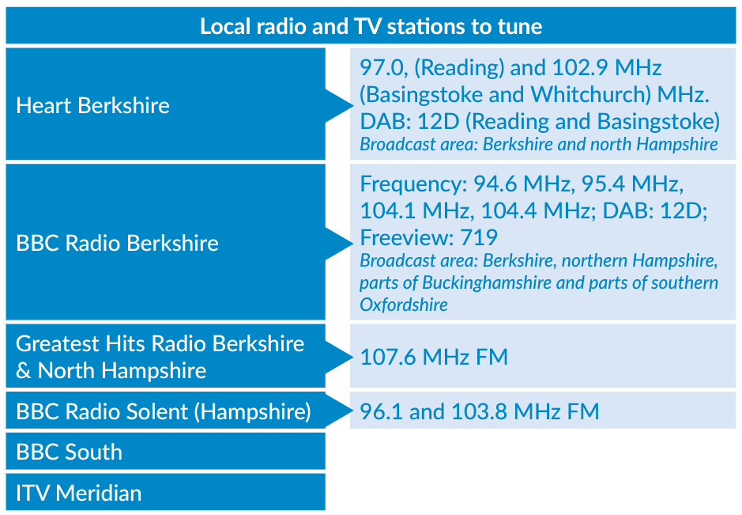

Immediate protective action to take
Everyone must go indoors immediately and stay there. This is because contamination levels are likely to be higher outside buildings than inside. Staying inside is the most important advice because the fabric of the building will provide a layer of protection against any ionising radiation and will reduce exposure to any radioactive particles.
Tents, caravans and barns do not constitute adequate shelter, due to airflow, and as such they must go into the nearest permanent building. If your event does not have a permanent building for shelter, you need to contact the SAG to discuss your plans.
If people are outside and in the downwind area, as advised by the emergency services, at the time of the incident they may benefit from self-decontamination. Taking off your outer layer of clothing can remove up to 90% of radioactive material. If they can, shower using mild soap and shampoo, do not use conditioner, as this may bind contamination to the hair. If they cannot, wash their hands, face, and other exposed body parts at a sink or tap.
The UKHSA has produced guidance on self decontamination which can be found here: https://www.gov.uk/government/publications/radiation-emergencies-information-for-the-public
As a precautionary measure, all within the Detailed Emergency Planning Zone area will be advised to shelter in the initial response stages of a radiation emergency. Sheltering may be necessary for up to 48 hours.
Close all windows and doors to stop radioactive particles from entering the building. Who undertakes these actions is required in your event/emergency plan.
Turn off boilers and air conditioning units and put out fires or wood burners. Fans, heating systems, boilers, gas fires and air conditioning all draw in air from outside so these should be shut down to minimise radioactive particles entering the building. Your event may need to consider ensuring any additional needs from shutting off these appliances, e.g. blankets for warmth, or access to additional water due to heat, is considered.
Listen to local TV and radio for instructions and updates. During a radiation emergency, advice will be broadcast regularly. This will include the care of children at school, food and water supplies and care of farm animals and pets.
Do not make phone calls by landline, mobile or via mobile data. This is important because the phone system could be overloaded, preventing the emergency services and other responders from receiving or making calls, or from contacting you. You can still call 999 in an emergency.
Stay where you are. The main risk at Atomic Weapons Establishment is from Alpha radiation, which is why you will be safer to stay where you are rather than travelling around outside, vehicles provide less protection against ionising radiation than houses and other solid buildings. If you try and leave the area, roads could quickly become gridlocked and prevent access for the emergency services. By leaving you could also end up in an area with more radioactive contamination. It is very unlikely that an evacuation would be necessary but if that does happen, details of what to do will be given.
How long will the need to shelter be for? Extensive environmental monitoring results will be used to confirm where sheltering needs to remain in place and to identify those areas where sheltering is no longer required. If sheltering is required after 48 hours, then your event is likely to be asked to evacuate where you are sheltering and move to somewhere else for a period of time.
Keep pets inside if they were not outside at the time of the emergency; those that have been outside should be kept in a separate room or building.
Make sure that everyone in your event understands what to do in the event of a radiation emergency.

Evacuation
The event should not evacuate unless you are told to do so. Normally the safest place is sheltering in a building, which may be for 48 hours depending on the situation. However, if your event needs to be evacuated urgently from the area, the event organiser will be told how this will be done and what you need to do by the emergency responders.
If your event is evacuated, you must send them to a location agreed with the emergency responders (including West Berkshire District Council) for decontamination and monitoring. This is important to ensure those evacuated are not contaminated before they disperse.
Transport for event attendees and staff to get to the agreed evacuation location needs to be considered by the event organisers.

Food and drink
Covered food and drink (e.g., fridge, freezer, larder, in containers) will be unaffected. Mains water supplies are also unlikely to be affected and should be safe to drink. Outside crops such as vegetables and fruit, may be contaminated, and therefore should not be eaten.
For those breast-feeding, they should switch to using breast milk substitutes as soon as possible, as any radioactive material you ingest, or inhale could be passed to the infant through the mother’s milk. However, if they don’t have access to formula, do not stop feeding the baby, as this will be far more harmful to them. The immediate priority should be to go inside and remain indoors until instructed otherwise.
Your event must hold sufficient covered food, and access to water (mains for sealed supply) for at least 48 hours for the needs of your event attendees.

Traning and exercising
Your event plan must demonstrate that staff have been trained and know what to do in the event of a radiation emergency.

Further information
Further information, and the AWE response framework, is available at www.westberks.gov.uk/awe.
More information about the Basic Concepts of Radiation can be found online by scanning the QR code below: | The UK Health Security Agency has produced information on nuclear emergencies which can be found by scanning the QR code below:

Appendix B – METHANE Form
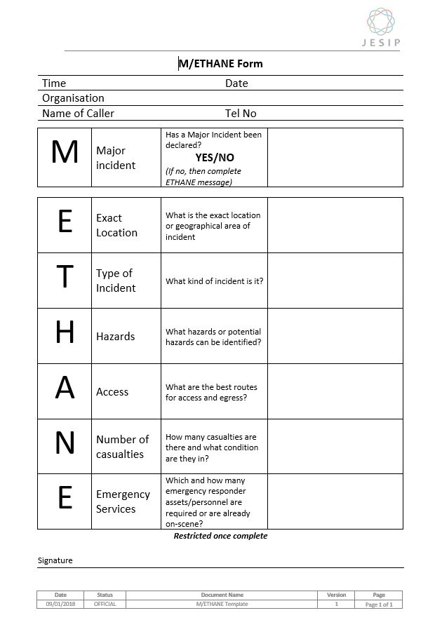
Contact
Telephone: 01635 503535

