Contaminated Land Public Register under Part 2A Environmental Protection Act 1990

Bracknell Forest Borough Council
No entries
West Berkshire District Council
1.Land known as A12Q1, AWE Aldermaston
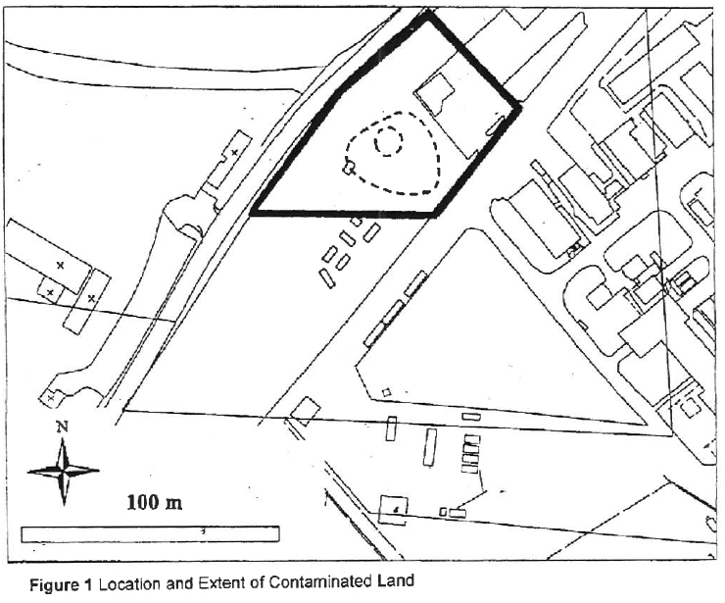
2.Sterling Industrial Estate
