Contaminated Land Strategy 2023 – 2028

CONTENTS
1. EXECUTIVE SUMMARY 5
1.1. Objectives 5
1.2. Overview 5
1.3. Progress in implementing the strategy to date 6
1.4. Approach Going Forward 6
2. INTRODUCTION 6
2.1. Background 6
2.1.1 The Legal Framework 6
2.2. Characteristics of West Berkshire District 7
2.2.1. Geography 7
2.2.2. Population 8
2.2.3. Past Industrial Land Uses 8
2.2.4. Current Land Uses 8
2.2.5. Geology 9
2.2.6. Hydrogeology 9
2.2.7. Protected Ecological Areas and Buildings 10
3. REGULATORY CONTEXT 10
3.1. Part 2A Legislation 10
3.1.1. Statutory Guidance 10
3.1.2. Definition of Contaminated Land 11
3.1.3. Principles of Contaminant Linkages 11
3.1.4. Principles of Risk Assessment 12
3.2. The Role of Local Authorities 12
3.3. The Role of the Environment Agency 12
4. DEVELOPMENT OF THE STRATEGY 13
4.1. Overall Approach 13
4.2. Council Policies and Strategies 13
4.2.1. West Berkshire District Council Vision 13
4.2.2. West Berkshire District Council Strategy (2019-2023, refreshed May 2021) 13
4.2.3 Environment Strategy for West Berkshire 14
4.2.4. Development Plan 14
4.2.5 Waste Strategy 14
4.2.6. Rights of Way Improvement Plan (ROWIP) 14
4.3. Interaction with Other Regulatory Regimes 14
4.3.1. Background 14
4.3.2 Town and Country Planning Act 1990 14
4.3.3 Environmental Permitting 15
4.3.4 Waste Management Licensing 15
4.3.5 Water Pollution 15
4.3.6 Building Regulations 15
4.3.7 Environmental Damage (Prevention and Remediation) Regulations 2015 15
4.4. Responsibility, Consultation and Liaison 16
4.4.1. Internal Teams Responsible 16
4.4.2. Internal Liaison 16
4.4.3. External Liaison 16
5. VISION AND OBJECTIVES 16
5.1. Vision 16
5.2. Objectives 16
5.3 Progress 17
6. PROCEDURES FOR IMPLEMENTATION 17
6.1. Investigation of Potentially Contaminated Land Sites 17
6.1.1. Identification of Potential Sources 18
6.1.2. Identification of Potential Receptors 18
6.1.3. Prioritisation of Potentially Contaminated Land Sites 18
6.1.4. Preliminary Risk Assessments undertaken under Part 2A 18
6.1.5. Intrusive Site Investigations 19
6.1.6. Quantitative Assessment of Risks on Individual Sites 19
6.2. Determination of Contaminated Land 19
6.2.1. Determining that land is contaminated land 19
6.2.2. Informing Interested Parties 20
6.2.3. Land Which May be a ‘Special Site’ 20
6.2.4 Written Record of Determination and Formal Notification 20
6.2.5. Apportioning Liability 21
6.2.6. Apportionment of Costs 21
6.2.7. Deciding that land is not contaminated land 21
6.2.8. Triggers for Undertaking Non-Routine Inspections 21
6.2.9. Triggers for Reviewing Decision Making 22
6.3. Dealing with Contaminated Land under Planning 22
6.4. Information Management 22
6.4.1. Strategy Document 22
6.4.2. Contaminated Land Register 22
6.4.3. Environmental Information 23
7. LIAISON AND CONSULTATION 24
7.1. External Consultation for Land Determined to be Contaminated Land 24
8. REVIEW 24
8.1. Review of Strategy 24
8.2 Triggers for Reviewing Inspections and Inspection Decisions 24
9 CONTACT POINTS 25
9.1 West Berkshire District Council 25
9.2 Other Relevant Contacts 25
10. APPENDICES 27
10.1 APPENDIX 1 27
10.2. Appendix 2 – Map of the West Berkshire District 29
10.4 Appendix 4 32
10.5 Appendix 5 32
10.6 Appendix 6 35
10.7 Appendix 7 35

1. EXECUTIVE SUMMARY
This document forms a revision of the West Berkshire District Council (“the Council”) Contaminated Land Strategy which was originally developed in 2000 and subsequently revised in 2002, 2006 and 2014.
It reviews the Council’s aims and objectives as well as progress made in implementing the strategy. It updates also the relevant action plans and procedures taking into account the Council’s current priorities and changes to the contaminated land statutory guidance.

1.1. Objectives
The aims and objectives of the strategy remain unchanged from previous strategies. The broad objectives are:
- To meet the statutory requirement to produce and revise a written strategy
- To demonstrate how the Council will meet the requirements of the Environmental Protection Act, 1990, (EPA) Part 2A, in particular the Contaminated Land Statutory Guidance (2012)

1.2. Overview
The contaminated land regime was introduced by central government as a means of dealing with the legacy of contamination which has arisen mainly from a wide range of historical industrial, mining and waste disposal activities. The Council’s Contaminated Land Strategy was last updated in 2014. This 2023 revised version consists of layout changes and updates to references to the legislation where appropriate. No significant changes to the Council’s overall approach have been made. The format and content of the strategy is both formal and technical in order to comply with the requirements of the legislation (which sets out what should be included) and to enable the document to be of assistance to those involved in managing contaminated land.

The Council has two specific roles: firstly, to undertake an assessment of its area for contaminated land through a strategic approach and, secondly, where contaminated land which poses an unacceptable risk to health/environment is identified, to ensure the contamination is remediated to reduce that risk to an acceptable level.

Taking a strategic approach has enabled the Council to identify in a rational, ordered and efficient manner where land contamination is more likely to be found. Then, by using what is known about those areas from a variety of sources, to risk rate them. By identifying and ranking potentially contaminated land in this way, resources have been focused on those areas which merit individual inspection.

The strategy provides background to the issues and details the key characteristics that make up the District. It provides clear priority actions and details the inspection programme and timescales, which have been and will continue to be adjusted according to findings as work progresses and as changes are made to the official guidance.

Addressing the issues of contaminated land is not a short-term project and the Council has looked to ensure that a holistic and rational long-term approach is adopted. Through the approach detailed in this document the Council continues its commitment to ensuring that all potentially contaminated sites receive a clear, efficient and all-encompassing assessment and that appropriate remediation is undertaken where necessary.

1.3. Progress in implementing the strategy to date
The Council has been successful in meeting the aims and objectives set by the previous versions of the strategy. It is complying with its legal obligations and has a clear risk based framework for ensuring that both Council owned and non-Council owned land is inspected in a rational, ordered and efficient manner. This includes a process for assessing sites which will ensure consistency of approach for dealing with future sites. The Council has consulted previously with relevant stakeholders and the strategy has been made available for the public to access.
A database of approximately 1386 potentially contaminated sites has been built up and prioritised in terms of the risk they pose to humans and the wider environment. 179 sites have been removed from the list of potentially contaminated sites as they were either not considered to be contaminated land or they have had remedial works carried out on them. This includes 32 high priority sites. A further 52 high priority sites have also been re-risk assessed to a lower risk following investigative work which included information research and site walk-overs. Experience has proved that the removal of high risk sites from the list requires more intensive work as they may require remediation to be carried out.

1.4. Approach Going Forward
Building on the progress achieved to date the Council’s approach going forward will focus on the management and provision of contaminated land information, remediating land through the planning regime and Part 2A activities.
In line with statutory guidance, the Strategy will be reviewed, and revised if necessary, at least every 5 years.

2. INTRODUCTION

2.1. Background

2.1.1 The Legal Framework
Contaminated land in the UK is primarily a legacy of the industrial past. Industrial processes such as gas works, chemical works and waste disposal have resulted in large number sites whose soils are contaminated with a wide range of hazardous chemicals.
The contaminants resulting from some of these industrial activities can lie hidden in soils, posing a health risk to humans that come into contact with them. They can pollute groundwater, surface waters (rivers, streams and lakes) as well as nature and ecological conservation areas.
Land contamination in England is estimated by Public Health England (2019) to account for approximately 296,000 hectares of land (equivalent to a city larger than Greater London). For many years a methodology for dealing with this legacy was sought so that inner city and urban areas could be brought back into beneficial use, thereby enabling the regeneration of land and communities, whilst simultaneously relieving the pressure to build on ‘greenfield land’.
After extensive consultation, on 1 April 2000, the contaminated land regime under Part 2A of the Environmental Protection Act 1990 came into force. The regime made provision for ensuring the remediation of historically contaminated land by imposing retrospective liability for historical contamination of land. It is intended that Part 2A complements the planning regime in that contaminated land can still be dealt with by the use of planning conditions as part of the redevelopment process. However, Part 2A allows local authorities and the Environment Agency to deal proactively with land that is not actively undergoing redevelopment, but is posing unacceptable risks to humans, controlled waters or the wider environment. This legislation is consistent with the ‘Polluter Pays Principle’ in that it seeks to place the cost burden of dealing with contamination on the polluter where they can be found, or the landowner/occupier where the polluter no longer exists.

Until Part 2A came into force, the public health implications of contaminated land were covered by Statutory Nuisance legislation. Historically these nuisance provisions originate from Public Health Acts ranging back to the 19th century, but are now contained within the Environmental Protection Act 1990. Section 79 of this Act introduced the definitions of nuisance. Statutory nuisance provisions place a duty on local authorities to inspect their area, from time to time, to identify any nuisances and to investigate any complaints of nuisance. Where the local authority is satisfied that a nuisance exists, or is likely to occur or reoccur, it must serve an Abatement Notice requiring that action be taken to remedy the nuisance. Where the notice is not complied with the authority can take action itself and institute 'works in default' to abate the nuisance, and then seek to recover its costs from the responsible person or persons. The contaminated land provisions of the Part 2A regime are modelled on the existing statutory nuisance provisions of the Environmental Protection Act 1990.
Although West Berkshire has never been a heavily industrialised area, the district does have its own legacy of contaminated land that needs to be dealt with. To date, 1386 potentially contaminated land sites have been identified within the district. This document provides an update on how the Council has dealt with and intends to continue to deal with these sites and any threats arising from contaminated land in the district.

2.2. Characteristics of West Berkshire District

2.2.1. Geography
West Berkshire District is located in the County of Royal Berkshire and covers an area of 70,417 hectares. The main centres in the district include Newbury, Thatcham, Hungerford, Pangbourne, Theale and Lambourn. Major transport links pass through the district including the M4, A34 and main railway lines to Bristol and Exeter. Bordering authorities include Oxfordshire to the north, Reading and Wokingham to the east, Hampshire to the south and Wiltshire to the west.
The River Kennet, which rises in Wiltshire, flows through West Berkshire to join the Thames at Reading. The majority of the district’s population live within the Kennet valley. To the south, the land rises to the border with Hampshire. The majority of the district land area lies to the north of the Kennet, consisting of chalk downlands, much of which forms part of the North Wessex Downs Area of Outstanding Natural Beauty (AONB).

A map of West Berkshire can be found in Appendix 2.

2.2.2. Population
According to the Census 2021 West Berkshire has a usual resident population of approximately 161,400 people, 23% are aged 19 and under, 62% are aged 20 to 64, and 20% are aged 65 and over.
64% of the West Berkshire population (around 101,111) live in settlements along the Kennet Valley, and in the suburban areas just to the west of Reading borough. The 2018-based projection for the number of households in 2020 is 65,638.
The largest urban areas in the district are Newbury and Thatcham, where around 69,670 (44%) of West Berkshire residents live. 31,440 (20%) of residents live in the suburban area adjoining Reading borough. Around 57,350 (36%) of people live in rural settlements. West Berkshire has one of the most dispersed populations in the South East, with 225 people per hectare.

2.2.3. Past Industrial Land Uses
For almost all authorities, the inspection process will begin with a consideration of the historical land uses that are likely to have generated contamination within their areas.
West Berkshire’s industrial history can be traced back to at least Roman times with the manufacture of pottery, iron and woodcrafts. The industrial revolution during the latter part of the 18th century impacted only parts of the district leaving many areas of West Berkshire largely untouched and free from contamination. Agriculture was the major employer and industries were related either to serving an agriculture economy or processing the crops produced in the area. The various types of clay deposits found in the district enabled the brick making industry to flourish until the 1950s. Gravel extraction in large quantities commenced during the 20th century and as a consequence there are several exhausted gravel pits some of which have been used as landfill sites.

2.2.4. Current Land Uses
Current land uses within the District have impacts on the type and sensitivity of receptors present on sites, as well as contaminants that may have been, or are being, released to the environment.
The table 1 below which was published by the Department for Levelling Up, Housing and Communities in 2022 shows the land use distribution in West Berkshire. Agriculture is the major land use in West Berkshire, followed by forestry/open land.

Table 1 – West Berkshire Land Use (Dept. of Levelling Up, Housing and Communities, 2022)

Land Use | Area (ha)
Agriculture | 46,673
Forest, open land and water | 13,662
Residential Gardens | 3,268
Transport and Utilities | 2,723
Outdoor Recreation | 1,319
Unknown developed land | 1,103
Residential | 562
Community Service | 471
Undeveloped land | 338
Industry and Commerce | 174
Minerals and Landfill | 49
Defence Buildings | 2

The district is an area with several information technology and communications companies, two examples of larger businesses being Quantel and Vodafone. There are a range of manufacturing industries, and tourism and recreation play an important part within the District which is renowned for its horse racing interests. There is a racecourse situated in the heart of Newbury, with gallops and training stables on the Downs around Lambourn, East Ilsley and West Ilsley. The Kennet and Avon canal runs through the District.
The military history of the District has resulted in a number of areas still owned by the Ministry of Defence. There are three main defence sites, AWE Burghfield, AWE Aldermaston and RAF Welford. The former airbase at Greenham Common has been decommissioned and is now owned by a trust. Greenham Common has been restored to an open space and the trust oversees a successful business park.

2.2.5. Geology
Due to the movement of contaminants through the subsurface, the geology of an area is important in determining whether sites are potentially contaminated and if they will impact, or are impacted by, surrounding areas. Much of the District is covered in chalk deposits overlain by London Clay, Reading Beds and clay with flints. There are also ‘drift’ deposits that include plateau gravels, valley gravels and alluvium.
A map of geological features within West Berkshire District can be found in Appendix 3.

2.2.6. Hydrogeology
The River Thames forms part of the northern boundary of the District. The River Kennet flows through Newbury on its way to Reading, and the River Lambourn joins the Kennet at Newbury.
Details of the locations of aquifers that are used for abstraction of water for public supplies and minor local water supplies are important for an understanding of potential receptors of contamination to generate a risk assessment. Information on the groundwater vulnerability is also important to quantify the sensitivity of the groundwater receptors. The chalk deposits of West Berkshire are part of the chalk group that forms the most important aquifer unit within the Thames Basin.
Source Protection Zones (SPZs) define areas which are considered to form the catchments to public water supplies and certain other private supplies. They show the position of the sources and all subdivisions of their protection zones (Inner, Outer and Total Catchment). There are a total of 25 SPZs either fully or partially contained within the district. Eight of these are Inner SPZs, 7 are Outer SPZs and the other 10 are Total Catchment Zones. SPZs are overseen by the Environment Agency.

2.2.7. Protected Ecological Areas and Buildings
It is important to identify protected locations to ensure that they are not at risk from a contaminative source. Some such protected sites may be found to be at increased risk of contamination which may in turn threaten the natural habitat or endangered species residing on the land.
West Berkshire contains a diverse range of environments and key property types, including areas or features protected by regulations. These include the North Wessex Downs Area of Outstanding Natural Beauty, approximately 52,000 hectares of which are in West Berkshire (around 74% of the District); approximately 50 sites of special scientific interest (SSSIs); three Special Areas of Conservation; approximately 500 local wildlife sites; 89 scheduled monuments; just under 2500 listed buildings; eleven historic parks and gardens and one Historic England battlefield near Newbury.

3. REGULATORY CONTEXT

3.1. Part 2A Legislation
In paragraph 2.1.1 it was noted that legislation, Part 2A of the Environmental Protection Act 1990, commonly known as “Part 2A”, was introduced to provide a legal framework for dealing with contaminated land.
Under the legislation, each Local Authority has a duty to “cause its area to be inspected from time to time for the purpose of identifying contaminated land”. Where sites that may be contaminated are identified, the guidance instructs Local Authorities to assess the risks they may pose to human health and the wider environment.
Where the risks associated with a site are considered to be “unacceptable”, the legislation allows Local Authorities to take legal action to ensure that they are remediated (i.e. reduced to acceptable levels). Where possible the Authority can require the persons who were responsible for the pollution to undertake the remediation. If those persons cannot be found, the responsibility may fall upon the current owners and/or occupiers of the land.

3.1.1. Statutory Guidance
Part 2A came into force in April 2000 following the issuance of Statutory Guidance by the Government to Local Authorities detailing how they should implement the legislation. This guidance was revised in April 2012 following a review of the way the contaminated land regime was seen to be functioning in England and Wales.
The 2012 guidance requires Local Authorities to take a strategic approach to inspecting their areas and to this end, requires each Local Authority to publish and keep updated a written strategy explaining how it intends to fulfil its duties under the legislation. This document is the written inspection strategy for West Berkshire District Council.
The guidance states that the starting point for any consideration is that land should be assumed not to be contaminated land unless there is reason to consider otherwise. It introduced a system of categorisation in which potentially contaminated land could be put into one of four categories depending on the level of risk associated with it. These categories are summarised below:
- Category 1 – Sites where there is an unacceptably high probability of significant harm or significant pollution of controlled waters occurring if no action is taken to stop it.
- Category 2 – Sites where the land is capable of being determined as contaminated land on grounds of significant possibility of significant harm.
- Category 3 – Sites where the land is not capable of being determined as contaminated land on grounds of significant possibility of significant harm.
- Category 4 – Sites where there is no risk of significant harm or significant pollution of controlled waters, or the level of risk is low.

3.1.2. Definition of Contaminated Land
Before a Local Authority can require remediation to be undertaken on a site, it has to officially “determine” (or declare) the site to be ‘contaminated land’.
The term ‘contaminated land’ is defined as:-
Any land which appears to the Local Authority in whose area it is situated to be in such a condition, by reason of substances in, on or under the land that:-
(a) Significant harm is being caused or there is significant possibility of such harm being caused: or

(b) Significant pollution of controlled waters is being caused, or there is a significant possibility of pollution to be caused.

3.1.3. Principles of Contaminant Linkages
In order for land to be considered “contaminated land” there must be a contaminant, a pathway and a receptor present.
- A contaminant is a substance situated in, on or under the land that is present at such concentrations that it has the potential to cause harm to a receptor.
- A receptor is a body that may be harmed by the contaminant. A receptor may be a human being, controlled waters (i.e. groundwater or surface water), designated ecosystem (e.g. a Site of Special Scientific Interest) or a property (e.g. housing, cattle).
- A pathway is a route, or means, by which the receptor may become exposed to (i.e. come into contact with) or affected by the contaminant.
When all three of the above components are present at a site, a Contaminant Linkage is said to exist.

Contaminant Linkage = Contaminant + Pathway + Receptor
In order for a Local Authority to make a decision that a site is contaminated land, it must be satisfied that the Contaminant Linkage is “Significant” (i.e. that the land identified is causing or is likely to cause significant harm to receptors if remedial action is not undertaken).

3.1.4. Principles of Risk Assessment
Part 2A requires Local Authorities to take a risk based approach to the identification and remediation of contaminated land. The guidance defines “risk” as a combination of:
- the likelihood that harm or pollution of water, will occur as a result of contaminants in, on or under the land; and
- the scale and seriousness of such harm or pollution if it did occur.
Where contamination is identified, the guidance instructs that any requirements for remedial action should be based on the ‘suitable for use’ approach. Land contamination is treated to deal with unacceptable actual or perceived threats to health, safety or the environment taking account of the actual or intended use of the site.

3.2. The Role of Local Authorities
Local Authorities have a duty to inspect their district for the purposes of identifying land that may be considered to be contaminated land. The guidance states that in so doing, Local Authorities should start with the assumption that the land being inspected is not contaminated land (i.e. does not pose a significant risk of significant harm). It is only when robust science-based supporting evidence is available, that land can be determined as contaminated land.
Once a Local Authority determines a site as contaminated land, it should act as the enforcing authority and require remediation. The Local Authority has to prepare a written record of determination (or risk summary) and a formal notification of which should be understandable to people without technical knowledge of contaminated land.
In specific instances (as outlined below), the Local Authority may designate a site as a ‘special site’, in which case the responsibility for enforcement passes to the Environment Agency.

3.3. The Role of the Environment Agency
The Environment Agency has the responsibility of acting as the enforcing authority in cases where the Local Authority has designated a site as a ‘special site’. There are five main categories of special site described in the regulations:
- Some water pollution cases – includes areas of contaminated land affecting drinking water supply or (potentially) polluting controlled waters within a major aquifer;
- Industrial sites – includes specific circumstances such as acid tar lagoons;
- Sites where explosives were manufactured, or a site for an authorised process under the Environmental Permitting (England and Wales) Regulations 2016;
- Defence sites – including most land currently owned by the Ministry of Defence and those of visiting forces;
- Radioactivity sites – where land is contaminated land by virtue of radioactivity which can include nuclear sites.
The Environment Agency also provides guidance to Local Authorities when requested.

4. DEVELOPMENT OF THE STRATEGY

4.1. Overall Approach
The West Berkshire District Council Contaminated Land Strategy was originally produced in 2000 and revised in 2002, 2006 and 2014. This document constitutes a further revision. It is based on the previous editions and takes into account progress that has been made in the interim as well changes in the Council’s visions, policies, other strategies and corporate plans.

4.2. Council Policies and Strategies

The following strategies are relevant to the Contaminated Land Strategy.

4.2.1. West Berkshire District Council Vision
The vision of the Council, set out in the document ‘Our West Berkshire Vision 2036’, outlines a series of priorities which demonstrate a collective aim of maintaining West Berkshire’s status as a great place to live, work and learn whilst rising to the challenges the district will face in the years to come.

4.2.2. West Berkshire District Council Strategy (2019-2023, refreshed May 2021)
The Council Strategy has six priorities for improvement which are seen as the first steps of a journey to deliver the West Berkshire Vision 2036. The six priorities are:
- Ensure our vulnerable children and adults achieve better outcomes
- Support everyone to reach their full potential
- Support businesses to start, develop and thrive in West Berkshire
- Develop local infrastructure, including housing, to support and grow the local economy
- Maintain a green district
- Ensure sustainable services through innovation and partnerships

The Council has organised its strategies, policies and plans in line with the six Council Strategy priorities and core business activities. The Contaminated Land Strategy sits within the priority to develop local infrastructure, including housing, to support and grow the local economy.

4.2.3 Environment Strategy for West Berkshire

The 2021 refresh of the Council Strategy notes that in terms of social, environmental and economic contextual changes, one of the most significant factors has been the Council declaring a climate emergency in July 2019. Flowing from this has been the adoption of the Environment Strategy and associated delivery plans which outline the steps the Council is taking, with its partners, to reach the target of carbon neutrality by 2030.

4.2.4. Development Plan
The Development Plan for West Berkshire comprises:
- The West Berkshire Local Plan, this is a long-term strategic document used by West Berkshire Council to set out its vision and a framework for the future development of the area. The current Local Plan covers up until 2026. It is being reviewed to cover the period until 2039
- The Housing Site allocations Development Plan Document, adopted in July 2017
- The West Berkshire District Local Plan 1991-2006 (Saved Policies 2007)
- South East Plan Natural Resource Management Policy 6 relating to the Thames Basin Heaths Special Protection Area
- A new Minerals and Waste Local Plan adopted in December 2022

4.2.5 Waste Strategy
Adopted in 2002, the Waste Strategy sets out the Council’s long term vision to maximise recycling and reduce the amount of waste produced in the District. Additional waste reduction targets were set as part of the Environment Strategy and the Waste Strategy is currently under review.

4.2.6. Rights of Way Improvement Plan (ROWIP)
The ROWIP sets out how the Council intends to improve the access network of public rights of way, cycle tracks and other routes used by the public.

4.3. Interaction with Other Regulatory Regimes

4.3.1. Background
In the fulfilment of its functions, the Council deals with contaminated land using other regulatory actions as detailed within sections 4.3.2 to 4.3.7 below. The Statutory Guidance states that enforcing authorities should seek to use Part 2A of the Environmental Protection Act 1990 only where no appropriate alternative solution exists. Therefore, Part 2A should not be used where existing legislation may be enforced or where contamination has arisen due to a breach of an existing licence or permit.

4.3.2 Town and Country Planning Act 1990
In its function as the Local Planning Authority, the Council must consider the implications of land contamination in the development of its Local Plan. Furthermore, it is a material consideration in the determination of individual development applications submitted for planning permission. Many contaminated sites have already been dealt with through the application of planning controls during redevelopment. It is anticipated that the redevelopment of brownfield sites and derelict land within West Berkshire will continue to remain the primary mechanism for dealing with contaminated land. Any remediation agreed as a planning condition will be dealt with under planning controls and not under Part 2A of the Environmental Protection Act 1990.

Within the Place Directorate the services work together to ensure that where redevelopment of land takes place within the District, the planning process deals effectively with any contamination so that the land is suitable for its intended use.

4.3.3 Environmental Permitting
Site operators of industrial processes regulated under the Integrated Pollution Prevention and Control (IPPC) regime (which has been maintained under the EU Withdrawal Act 2018) are required to carry out a site survey to ascertain the baseline conditions of the land before being granted an operator’s licence. Should the operator cause contamination of the site by breaching the conditions of the licence, the operator is required to remediate the land so that it is returned to its original baseline condition. This regime is enforced by the Environment Agency for industrial processes classified as A1 and by West Berkshire Council for industrial processes classified as A2. There are no A1 or A2 process sites in West Berkshire.

4.3.4 Waste Management Licensing
Where contamination of land has been caused through waste disposal activities and resulted from a breach of an operating licence, the Council cannot seek the remediation of that land by the service of a Remediation Notice. However, powers are available under the Waste Management Licensing Provisions of the Environmental Protection Act 1990 for dealing with the contamination of that land.

4.3.5 Water Pollution
Section 161 of the Water Resources Act 1991 gives the Environment Agency powers to take action to prevent or remedy the pollution of controlled waters. There is considerable overlap between the Water Resources Act and Part 2A in respect of dealing with contaminated land that has the potential to pollute controlled waters. Where contaminated land is causing pollution of or has the potential to pollute controlled waters then remediation will be brought about under Part 2A by the Council, through consultation with the Environment Agency.

Where there is historical pollution of groundwater, but where Part 2A does not apply, remediation will be carried out by the Environment Agency under the Water Resources Act. This may occur, for example, where the pollutants are entirely contained within the relevant body of groundwater or where the ‘source’ site cannot be identified.

4.3.6 Building Regulations
In addition to the planning regime, Building Regulations (made under the Building Act 1984) require developers to take measures (e.g. installation of ground gas protection measures) to protect new buildings and their future residents from the effects of contamination.

4.3.7 Environmental Damage (Prevention and Remediation) Regulations 2015
These regulations relate to liability for environmental damage and are enforced by the Environment Agency and Natural England.

4.4. Responsibility, Consultation and Liaison
The Council’s first contaminated land strategy was produced by a Contaminated Land Working Group which consisted of representatives from relevant Council services. Comments from internal and external statutory and informal consultees were incorporated into the strategy.

4.4.1. Internal Teams Responsible
Within West Berkshire District Council, the Contaminated Land Strategy is implemented by officers from the Public Protection Partnership, Development Control and Planning Policy teams within the Development and Regulation Service of the Place Directorate.

4.4.2. Internal Liaison
Relevant services within the Council, where appropriate, have been consulted in updating the strategy and continue to be involved in its implementation.

4.4.3. External Liaison
The Council will continue to take a pro-active approach to communication with local residents, land owners, businesses, the media and other interested parties regarding contaminated land issues.
West Berkshire District Council undertakes to inform relevant owners and occupiers of any on-site investigations being carried out in the district and to provide answers to any queries they may have. This will be done before any detailed intrusive investigations on the site begin. The Council will also provide details of Council officers who will act as contact points for queries, and where appropriate, will arrange for meetings to discuss relevant issues.
The Council’s website is used to provide general information on contaminated land and has a specific form to enable requests for information on specific sites.

5. VISION AND OBJECTIVES

5.1. Vision

Our vision is that contaminated land in West Berkshire is managed and remediated such that the health of the local population is protected and the condition of the local environment is improved.

5.2. Objectives
- Preventing the creation of new contaminated land.
- Identifying land within the District that is causing an unacceptable risk to human health, controlled waters, or the environment.
- Ensuring that, where present, the most urgent problem land is identified first, taking into consideration the seriousness of any actual or potential risk.
- Ensuring that contaminated land is returned to beneficial use.
- Ensuring that all land owned by the Council is inspected for contamination and ensuring that the risk of harm to human health, controlled waters, or the environment is minimised.
- Ensuring that contaminated land is given due consideration in all land development, redevelopment and acquisition decisions.
- Ensuring that the Council’s handling of information and its consultation and involvement with relevant organisations and agencies are open, transparent, consistent, and comprehensive.
- Ensuring that the Council provides information to the Environment Agency for its report on contaminated land.
- To periodically review the Contaminated Land Strategy.

5.3 Progress
The Council has succeeded in meeting the general aims and objectives of the previous versions of the strategy. It is complying with its legal obligations and has a clear risk based framework for ensuring that both Council owned and non-Council owned land is inspected in a rational, ordered and efficient manner. This includes a consistent process for assessing sites.
The Council will continue with its current approach taking into account changes to the Statutory Guidance as well as central government and the Council’s changing priorities.
An example of changing priorities is the issue of central government funding for the remediation of contaminated land. DEFRA ran a Contaminated Land Capital Projects Programme to help local authorities in England cover the cost of implementing contaminated land legislation, the programme ceased in 2017.
Land Remediation Relief continues to be available to businesses. This allows, in certain circumstance, companies to claim corporation tax relief relating to the cost of cleaning up contaminated land or buildings.
The core mechanism for managing and/or remediating contaminated land since 2014 has been the planning system through development control. Perhaps the most significant example of the remediation of contaminated land since 2014 is the Sterling Cables site in Newbury. Appendix 4 provides a brief comment on the redevelopment of this site which was one of the most heavily contaminated in Southern England.
The targets set out in the 2014 version of the strategy and progress against them are shown in Appendix 5. Operational targets for the next five year strategy period are set out in Appendix 6.

6. PROCEDURES FOR IMPLEMENTATION
This section outlines the procedures for implementing the updated strategy.

6.1. Investigation of Potentially Contaminated Land Sites
Local Authorities have a continuing duty inspect their areas for the purpose of identifying land that may be contaminated and to take action where necessary.
The Public Protection Partnership (the PPP) is responsible for implementing work under Part 2A. This includes undertaking desk studies, carrying out visits to sites thought to be of risk. This work may be completed by an officer of the PPP or outsourced to a suitably qualified person. If a site is determined as contaminated, it is the job of the PPP to serve a remediation notice on the site following consultation with the Council’s Legal Team.
The following section describes the procedures that the Council will use to identify and prioritise potential contaminated land sites for further action.

6.1.1. Identification of Potential Sources
Potential sources of contamination have been collated by systematically examining historical maps covering the period 1843 to 1991, as well as current land use mapping and Groundwater Vulnerability Maps. Data obtained from the Environment Agency has been used to identify locations of current and former landfill sites.
To date, 1324 potentially contaminated sites have been identified. The Council will continue to review available information sources for the purposes of identifying new potential contaminated land sites.

6.1.2. Identification of Potential Receptors
The locations of potential receptors within the District continue to be identified using local knowledge combined with the systematic examination of Ordnance Survey mapping, aerial photography and map databases provided by Natural England and the British Geological Survey.

6.1.3. Prioritisation of Potentially Contaminated Land Sites
All sites are prioritised so as to ensure that those sites that present the greatest potential risk are inspected first.

6.1.4. Preliminary Risk Assessments undertaken under Part 2A
Preliminary Risk Assessments (PRAs) consist of desk based studies as well as a site walkover. A desk study of a site involves the collation and assessment of information about the possible presence of contamination by looking at records of the site on OS maps, planning history, and previous site investigation reports. This is combined with information about site conditions (for example, geology and hydrology) and current land uses.
The site walkover consists of a visual inspection of the site. This helps in the verification of the status of the site and the locations of potential receptors (e.g. dwellings and occupiers, water courses) as well as existing mitigation measures (such as landfill gas venting systems).
The assessor will examine all available information on the site to determine whether there are reasons to believe that contamination may be present and the extent of the spread of any pollution.
The output of each PRA will include a report which contains a Conceptual Site Model (CSM) which details likely contaminants, receptors and pathways as well as associated uncertainties. The CSM will examine what potential contaminants and receptors are likely to be present and the routes by which receptors may be exposed to the potential contaminants (i.e. pathways). Where potential contaminants, pathways and receptors are considered likely to exist on a site, then “potential contaminant linkages” are said to exist at the site.

6.1.5. Intrusive Site Investigations
Following the completion of preliminary risk assessments, intrusive site investigations may be required to further assess risks, and to determine whether further action is necessary.
Intrusive investigation involves collecting and analysing soil, water and gas samples (as appropriate) from the site in order to determine whether or not contaminants of concern are actually present in the ground, and if so, at what concentrations. This may include a number of processes, including off site groundwater monitoring, gas monitoring and soil sampling.
Every site investigation is specifically designed and considers multiple aspects including:
- Health and safety requirements
- Land-use, area and access, geology
- Communication and liaison with all concerned parties (such as site owners and occupiers, and the Environment Agency).
- Relevant standards and guidance
Officers may use their powers of entry under Part 2A legislation to undertake intrusive site investigations.
Where the Council intends to investigate land which would become a ‘special site’ if determined, it will notify the Environment Agency.

6.1.6. Quantitative Assessment of Risks on Individual Sites
Once an intrusive site investigation has been undertaken, a Generic Quantitative Risk Assessment (GQRA) will be carried out in order to evaluate the risks associated with any contamination identified on a site.
The GQRA is a process that allows risk assessors to determine whether the potential contaminant linkages identified in the conceptual site model actually exist and whether they should be considered to be significant or not. The model uses assumptions about the behaviour of contaminants and receptors on the site.
Following the GQRA it may be possible to establish whether or not the site is likely to represent a significant possibility of significant harm and if so, whether it should be determined as Contaminated Land under Part 2A. Officers can investigate further if appropriate.

6.2. Determination of Contaminated Land

6.2.1. Determining that land is contaminated land
Under the Part 2A, there are four grounds on which land (excluding radioactively contaminated land) can be defined as contaminated:
- Significant harm is being caused to a human, or relevant non-human*, receptor.
- There is a significant possibility of significant harm being caused to a human, or relevant non-human, receptor.
- Significant pollution of controlled waters is being caused.
- There is a significant possibility of significant pollution of controlled waters being caused.
* non-human refers to animals, plants, rivers or property
It is only when risks at a site have been assessed and are considered to fulfil the requirement of significant harm or significant possibility of significant harm, will a site be determined as being contaminated land.

6.2.2. Informing Interested Parties
Before making a determination, the Council will inform the owners and occupiers of the land and any other person who may be liable to pay for its remediation of its intention to determine the land unless there is an overriding reason for not doing so. This will allow for these persons to make representations to the Council that may avoid the need for a formal determination.

6.2.3. Land Which May be a ‘Special Site’
Before determination of a ‘special site’, the Council will consult the Environment Agency to establish any statutory powers and duties it maintains, such as Waste Management Licences, Water Resources Act etc.
If an area of contaminated land fulfils the criteria for a ‘special site’ after determination, the Council will inform the Environment Agency for agreement as to whether the site should be classified as a ‘special site’. If agreed, the responsibility for securing remediation of the site will be passed onto the Environment Agency.

6.2.4 Written Record of Determination and Formal Notification
If the Council decides to formally determine a site that is not a ‘special site’, then it will commence regulatory action. This will begin with preparing a written record to include:
- location, boundaries and area of the land in question
- the risk summary for the site and where not already covered in the risk summary, a description of the evidence which confirms the existence and significance of the Contaminant linkage(s);
- a summary of the way the requirements of the statutory guidance were satisfied.
The Council will then, in writing, formally notify all relevant parties that the land has been declared contaminated. These will include:
- the owner(s)
- the occupier(s)
- those liable for remedial action (‘appropriate persons’ in the guidance) • the Environment Agency
It may not be possible to identify all of the relevant parties during the notification stage therefore the Council will act on the best information at the time. If further information becomes available, the Council will review the situation.
If the Council believes the site is a ‘special site’, they will notify the Environment Agency. If the Environment Agency agrees with the Council, the responsibility for securing remedial action will pass from the Council to the Agency, however, the Council will still be required to complete the formal notification process.
The legislation encourages voluntary remediation where available, the Council will provide information to the relevant parties, such as; the written record of determination, an explanation of why the relevant person(s) have been chosen, details of site investigation reports etc. Remediation notices are served only as a last resort and after a detailed consultation process has taken place. The Council must be satisfied that without the notice any remedial actions would not be carried out and that the Council has no power to carry out the work itself.

6.2.5. Apportioning Liability
When all significant contaminant linkages on the site have been identified, the process of apportioning liability will begin. For each linkage, a ‘liability group’ comprising appropriate persons will be established.
- Class ‘A’ persons – These are generally speaking the polluters, but also included are persons who “knowingly permit”. This includes developers who leave contamination on a site, which subsequently results in the land being declared contaminated.
- Class ‘B’ persons – Where no Class ‘A’ persons can be found, liability reverts to the owner or the occupier. These are known as Class ‘B’ persons.
- ‘Orphan linkages’ – These exist when it is not possible to find Class ‘A’ or Class ‘B’ persons responsible for the land, or the persons found are exempt from liability.
The Council will make reasonable attempts to identify Class ‘A’ persons before the liability reverts to Class ‘B’.
Any specified remediation will be both appropriate and cost effective, taking the shortest and most sustainable and economic route. Consequently, attention will normally be focussed on breaking the pathway, rather than on the contaminant or receptor. The Authority must undertake a cost-benefit analysis in respect of all remedial actions, through considering the potential for hardship caused and the costs they are able to recover.

6.2.6. Apportionment of Costs
Costs will be apportioned between members of the liability group unless agreements exist between the appropriate persons. Tests also exist to exclude groups from liability, including Class ’B’ persons who do not have an interest in the capital value of the land, such as tenants.
If the Council considers that one or more of the parties cannot afford the cost of remediation, it will not serve a remediation notice upon any of the parties. Instead, it will consider completing the work itself and producing a remediation statement.

6.2.7. Deciding that land is not contaminated land
If, following the completion of the detailed inspection and assessment of a site, there is little or no evidence to suggest the potential for harm exists at the site, then the Council will issue a written statement to this effect as required under the statutory Guidance.

6.2.8. Triggers for Undertaking Non-Routine Inspections
The Council has a duty to locate and inspect contaminated land within the District ‘from time to time’ under Part 2A but in some circumstances, it may be required to carry out inspections without the general strategic framework.
The circumstances that may trigger non-routine inspections are likely to include new receptors and new sources of contamination coming to light. These could include land use changes and planning applications, as well as the receipt of complaints or information from statutory bodies, land owners, members of the public or other relevant parties.
If unplanned events occur that alter contaminant linkages to a higher significance, such as flooding or spillage of contaminants, it would be advisable to undertake non-routine inspections to assess the significance of the linkage.
Voluntary remediation of sites may be carried out by viable parties and as such, the change in circumstances should trigger a non-routine inspection.

6.2.9. Triggers for Reviewing Decision Making
When deciding if a site is classified as contaminated, certain criteria should be met. If these criteria change, such as due to changes in legislation, establishment of case law, revision of guidance values for exposable assessment or any additional information that becomes available, the sites should be re-assessed to ensure they follow the new criteria.

6.3. Dealing with Contaminated Land under Planning
When redevelopment sites from the planning regime are identified as lying within the vicinity (within 100m) of a potential contaminated land site, liaison and co-operation between the Public Protection Partnership and the Development Control Team is required to ensure a suitable investigation into risks provided by any contamination.
The process of reviewing planning applications on sites that may be affected by land contamination is on-going. Some applications will require a simple review, others may take several days. All specialist reports submitted for discharge of contaminated land conditions are currently reviewed by the Public Protection Partnership.
The planning process (development control) is the main route for the remediation of contaminated land in West Berkshire.

6.4. Information Management

6.4.1. Strategy Document
This document will be made publicly accessible by publishing it on the Council’s website. It will be available also at the Council Offices in Newbury where it may be viewed by the public during normal office hours. Requests for copies of the document should be made to the Public Protection Partnership and a reasonable charge will be made.

6.4.2. Contaminated Land Register
Under Section 78R of the Environmental Protection Act 1990, information regarding contaminated land is to be maintained within a Register. This information includes:
- Remediation notices (and any appeals)
- Remediation declarations statements
- Appeals against charging notices
- Designation of ‘Special Sites’
- Notification of claimed remediation
- Convictions for any offences under Section 78M
- Guidance issued under Section 78V(1)
Under Sections 78S and 78T of the Environmental Protection Act 1990, the Authority must not include information relating to affairs of individuals or their businesses or commercially confidential information without permission.
The Register will be maintained by the Public Protection Partnership. It is available on line and at the Council offices in Newbury where it may be viewed by the public during normal office hours. Requests for copies of the document should be made to the Public Protection Partnership and a reasonable charge will be made.

6.4.3. Environmental Information

6.4.3.1 Disclosure of Environmental Information
From time to time, the Council may be asked to provide information it has gathered about areas of land to interested parties (for example, in connection with property purchases). Such requests for information are subject to the controls of the Environmental Information Regulations, 2004.

The Environmental Information Regulations, 2004 place a duty on all public authorities with responsibilities for the environment to make available to anyone on request the environmental information (as defined by the Environmental Information Regulations) that body holds. Where a request for information in respect of contaminated land is made to the Council, the appropriate regulatory guidance will be followed in providing the information. Such requests are currently dealt with through the Freedom of Information Request Regulations.

In providing such information, the Council may make a reasonable charge in respect of the costs involved.

6.4.3.2 Provision of Information to Other Council Departments
Information held within the contaminated land database will be made available throughout the Council on request.

6.4.3.3 Provision of information to the Environment Agency
The Environment Agency is charged with, from time to time, the responsibility of preparing and publishing a report on the state of contaminated land in England and Wales; that is on the nature, extent, and distribution of contaminated land, the level of remediation, and regulatory activity taken under Part 2A. To facilitate the Environment Agency in this activity, all local authorities within England and Wales provide the Environment Agency with the information necessary to produce the report.

The Council will provide the following requested information, in the agreed suggested formats, to the Environment Agency:

- A copy of the Council’s Contaminated Land Strategy.
- Information on each site determined as contaminated land.
- Information on remediation activity for each site determined as being contaminated land
- Information is to include details of remediation notices, and details of the remediation statement or declaration

7. LIAISON AND CONSULTATION

7.1. External Consultation for Land Determined to be Contaminated Land
The Council recognises that decisions made about contaminated land involve not just regulatory issues for the protection of human health and the environment, but involve considerations that are of a commercial, financial, legal and societal nature. As such, it is the Council’s intention to deal with all issues relating to contaminated land in an appropriately open and consistent manner. To achieve this, it will operate an open communication approach, whereby it will consult with and keep informed those stakeholders and interested parties who may be affected by a contaminated site. Such stakeholders and interested parties may include:

- Owners and occupiers of the land designated as being contaminated
- Appropriate person(s)
- The Environment Agency
- Thames Water (where potential pollution linkage includes a public water supply source as a receptor)
- Other statutory bodies as appropriate, any one or more of these may be consulted where, for example, the site in question may be contaminated by an ‘ecological system effect’, ‘animal or crop effect’. Examples of appropriate bodies include the Department of Environment, Food and Rural Affairs; The Food Standards Agency; Natural England and Historic England.
- Ward Members
- Town and Parish Councils
- The local community and pressure groups where appropriate

The approach the Council will use is to be based upon that outlined within the Environment Agency’s guidance “Communicating Understanding of Contaminated Land Risks”, 2010.

8. REVIEW

8.1. Review of Strategy
In line with the statutory guidance, it is suggested that the strategy should be reviewed at least every 5 years. As well as the routine review of the strategy there may be situations arising that trigger early review of the document to ensure the strategy covers the specified objectives.
If legislation changes before the review period is due, it is likely that the strategy will need to be updated or amended to incorporate new requirements as well as information from statutory bodies, public or other interested parties.

8.2 Triggers for Reviewing Inspections and Inspection Decisions
It may be necessary to carry out inspections in respect of potentially contaminated land outside the general strategic framework. Additionally, in certain circumstances it may be necessary to review routine inspection findings in respect of sites as appropriate. The following circumstances may act as triggers for both of these inspection reviews:

- Proposed changes in the use of surrounding land.
- Unplanned changes in the use of land (e.g.: persistent, unauthorised use of land by children).
- Unplanned events (e.g. localised flooding/landslides and accidents/fires/chemical spillage where consequences cannot be addressed through other relevant environmental protection legislation).
- Reports of localised health effects that appear to relate to a particular area of land.
- Verifiable reports of unusual or abnormal site conditions received from business, members of the public, or voluntary organisations.
- Responding to information from other statutory bodies.
- Responding to information from owners or occupiers of land, and other relevant interested parties.

9 CONTACT POINTS

9.1 West Berkshire District Council

West Berkshire Council Tel. 01635 551111
Council Offices
Market Street
Newbury
Berkshire
RG14 5LD
e-mail: customer.services@westberks.gov.uk

9.2 Other Relevant Contacts

The Environment Agency Tel: 01491 828696
Red Kite House
Howbery Park
Crowmarsh Gifford
Wallingford
OX10 8BD

Historic England Tel: 01793 445050
The Engine House
Fire Fly Avenue
Swindon SN2 2EH
email: customers@HistoricEngland.org.uk

Natural England Tel: 0300 060 3900
6th Floor
Northgate House
21-23 Valpy Street
Reading
RG1 1AR

DEFRA Tel: 03459 33 55 77
Seacole Building
2 Marsham Street
London
SW1P 4DF

Thames Water Tel: 0800 009 3921
Developer Services
Clearwater Court
Vastern Road
Reading
RG1 8DB

The Planning Inspectorat e Tel: 0303 444 500
Temple Quay House
2 The Square
Temple Quay
Bristol
BS1 6PN
https://contact-us.planninginspectorate.gov.uk/hc/en-gb/requests/new

The Food Standards Agency Tel: 0330 332 7149
Floors 6 and 7, Clive House
70 Petty France
London SW1H 9EX
email: helpline@food.gov.uk

10. APPENDICES

10.1 APPENDIX 1

Sources of Procedural and Technical Guidance

DEFRA, 2009, Protecting our Water, Soil and Air. A code of good agricultural practice for farmers, growers and land managers

DEFRA, 2012, Environmental Protection Act 1990: Part 2A, Contaminated Land Statutory Guidance

DEFRA, 2021, Land Contamination Risk Assessment (LCRM), ‘Before you start’

DEFRA, 2021, Land Contamination Risk Assessment (LCRM), ‘Stage 1 risk assessment’

DEFRA, 2021, Land Contamination Risk Assessment (LCRM), ‘Stage 2 options appraisal’

DEFRA, 2021, Land Contamination Risk Assessment (LCRM), ‘Stage 3 remediation and verification’

Environment Agency, 2005, Indicators for Land Contamination

Environment Agency, 2009, Using Soil Guideline Values

Environment Agency, 2009, Updated technical background to the CLEA model

Environment Agency, 2014, Remedial Targets Methodology: Hydrogeological Risk Assessment for Land Contamination – main report

Environment Agency, 2014, Hydrogeological Risk Assessment for Land Contamination. Remedial Targets Worksheet v3.2

Environment Agency, 2014, Remedial Targets Worksheet V3.1:User Manual

Environment Agency, 2015, CLEA Software (Version 1.05) Handbook

Environment Agency, 2016, GPLC2 – FAQs, technical information, detailed advice and references

Environment Agency, 2017, Land contamination groundwater compliance points: quantitative risks to groundwater from land contamination

Environment Agency, 2017, Protect groundwater and prevent groundwater pollution

10.2. Appendix 2 – Map of the West Berkshire District
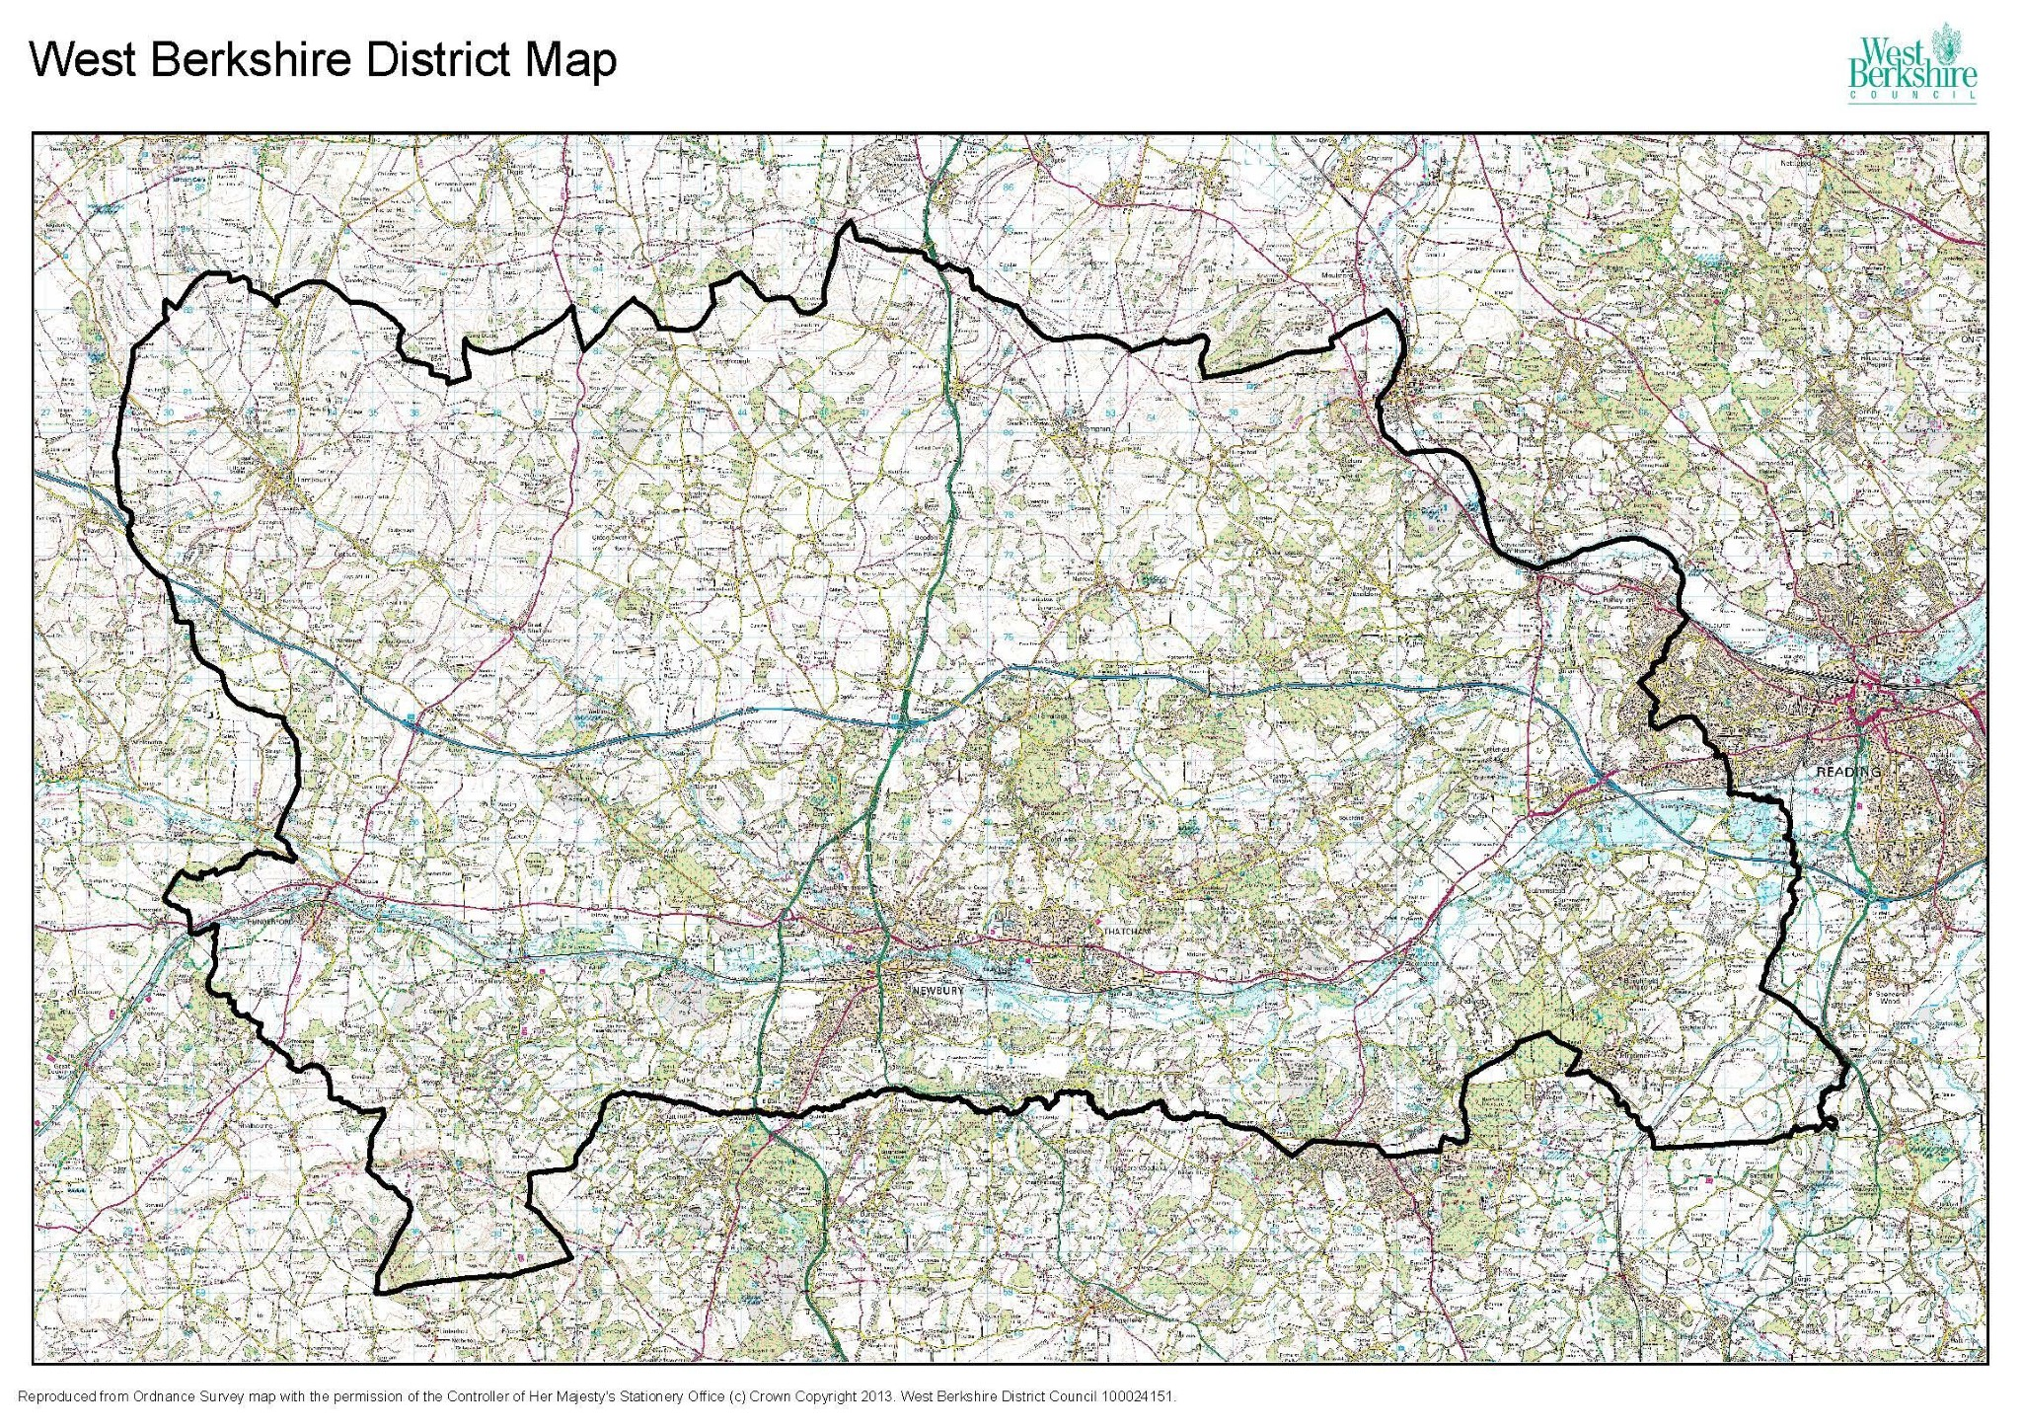
0 2.5 5 10
Kilometres (km)

10.3. Appendix 3 – Maps of geology of West Berkshire District
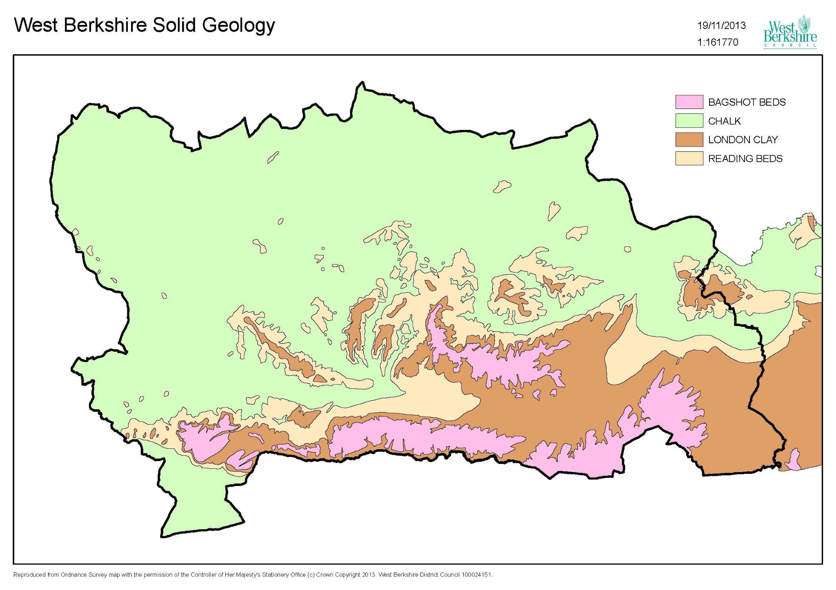

0

2.5

5

10

Kilometres (km)

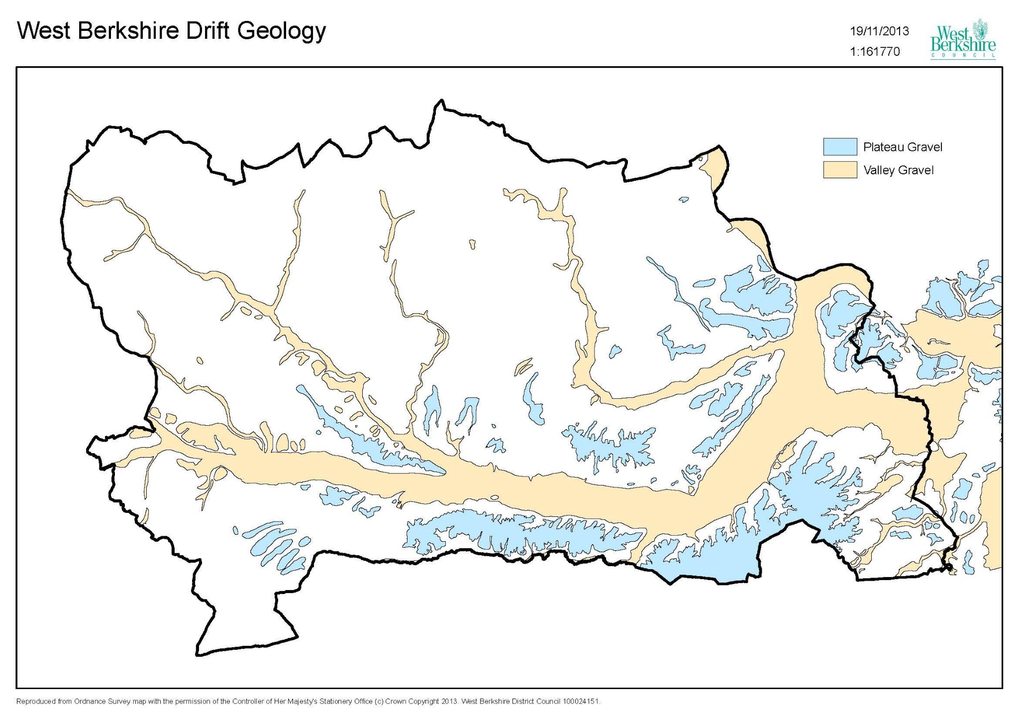
0 2.5 5 10
Kilometres (km)

10.4 Appendix 4

Update on remediation of contaminated site since last Strategy - Sterling Industrial Estate
The area of the former Sterling Industrial Estate is located on Kings Road, Newbury. It was historically operated as a gasworks between 1880 and 1960. It then became Sterling Cable Engineering works until late 1970s prior to its most recent use as Sterling Industrial Estate.
Following notification from the Environment Agency in early 2000 of gas-work type contamination they undertook an investigation, on behalf of the Council, under the Contaminated Land Regulations 2000.
A site investigation was undertaken in December 2009 and concluded that there was sufficient evidence to indicate that the site met the statutory definition of contaminated land with respect to controlled waters. Furthermore, the site would meet the requirement of being a ‘Special Site’ which meant that after determination, regulation would fall under the remit of the EA. Accordingly, Sterling Industrial Estate was declared as ‘contaminated land’ by the Council in 2011.
Further site investigations and a remediation options assessment were completed by the EA in 2013. Planning consent was granted for residential properties in 2015. This included site investigation, remediation and verification planning conditions. The main phase of remediation earthworks and enabling works were completed by April 2019.
Subsequent works included post remediation ground water monitoring, installation of capping layers, vapour/gas protection measures in the new buildings and the use of appropriate water supply pipes.
The site is now in residential use.

10.5 Appendix 5

Progress against 2014 targets
The targets set in the 2014 strategy and progress against them are outlined in the table below.

Targets | Target End Date and Progress
Target 1 – Management and Provision of Information:  Ensure that the Uniform contaminated land database is regularly maintained and that any updates provided by the software company are installed.  Respond to all formal requests for Environmental Information relating to potential contamination in accordance with the current Environmental Information Regulations and within agreed Council timescales.  Provide and maintain information and advice on land contamination available via the Council’s web site.  Set up and maintain a public register of declared contaminated sites on the Council’s website.  At the end of each calendar year carry out a review of contaminated land activity carried out by the Environmental Quality Team in accordance with this strategy and provide a summary report to the Joint Services Review Panel. | Ongoing  All completed with periodic reviews /updates provided.
Target 2- Activity Associated with Development of Land:  Provide on-going support and advice to the Planning Authority regarding the future development of potentially contaminated sites.  Respond to all formal planning consultations for proposed development on potentially contaminated sites within the statutory consultation period.  On behalf of the Planning Authority review contaminated land reports submitted to discharge planning conditions and make appropriate recommendations within agreed timescales.  Ensure that all site specific contaminated land reports submitted to the Planning Authority are entered onto the contaminated land database and that the risk assessment score for each site is adjusted accordingly.  Encourage and support the development of local planning policy on the development of potentially contaminated sites in accordance with the National Planning Policy framework. | Ongoing  All the items have been achieved on an ongoing basis, including details for the proposed Local Plan via the call for sites.
Targets | Target End Date
Target 3- Activity under Part2A of the Environmental Protection Act 1990  Depending on resources available and estimated level of risk to human health and complexity of the site aim to carry out one full site investigation per year to determine whether or not the land is contaminated.  Depending on resources available establish the number of site walk-over surveys to be carried out during the period 2014-2015. Thereafter the number of surveys to be carried out will be increased by 5% per annum until all surveys are completed. | Ongoing  All high priority sites have had an initial walk-over.  Sterling Industrial Estate was determined as being contaminated and has been remediated as part of a redevelopment scheme. See Appendix 4.  Resource limitations have prevented further surveys being undertaken on a planned basis. The development control process is the main route for ensuring the remediation of contamination.  The Public Protection Partnership Delivery Plan 2021-23, under the Environmental Protection section for prevention work, identifies the Contaminated Land Strategy to be updated.
Target 4- Maintaining Competency and Quality Control  Develop and maintain relevant processes and procedures as part of an externally accredited QMS system  Ensure that regular audits of processes and procedures relating to contaminated land are carried out in accordance with the agreed QMS audit plan. Participate in external audits carried out by the accrediting body.  Ensure that all staff involved with contaminated land work are appropriately trained and that their competency in the subject area is maintained.  Ensure that staff keep up to date with the latest research into land contamination and with relevant changes to legislation and standards. | Ongoing  No external accreditation obtained, however, the procedures are reviewed regularly and internal training is undertaken.

10.6 Appendix 6

Going forward
The planning process will continue to be the primary route for managing contaminated land. As such, the Public Protection Partnership will continue to:
- Provide on-going support and advice to the Planning Authority regarding the future development of potentially contaminated sites.
- Respond to all formal planning consultations for proposed development on potentially contaminated sites within the statutory consultation period.
- On behalf of the Planning Authority review contaminated land reports submitted to discharge planning conditions and make appropriate recommendations within agreed timescales.
- Ensure that all site specific contaminated land reports submitted to the Planning Authority are entered onto the contaminated land database and that the risk assessment score for each site is adjusted accordingly.
- Encourage and support the development of local planning policy on the development of potentially contaminated sites in accordance with the National Planning Policy framework.

In relation to the management and provision of information the Public Protection Partnership will:
- Ensure that the contaminated land database is regularly maintained and that any updates provided by the software provider are installed.
- Respond to all formal requests for Environmental Information relating to potential contamination in accordance with the current Environmental Information Regulations and within agreed Council timescales.
- Provide and maintain information and advice on land contamination available via the Council’s web site.
- Maintain a public register of declared contaminated sites on the Council’s website.
The Public Protection Partnership will review this updated contaminated land strategy within 5 years.

10.7 Appendix 7

The Environment Agency’s Strategy for contaminated land

Groundwater and Contaminated Land Issues

Land Quality Part 2A Documents

The Part 2A process documentation sets out, within the Agency’s Integrated Management System (IMS), how the Agency intends to carry out its responsibilities under Part 2A of the Environmental Protection Act 1990, which came into force in England on 1 April 2000.

Users of the Part 2A process documentation should first refer to the Part 2A Process Handbook to obtain a clear understanding of the activities involved in the Part 2A regime, and with which Agency officer responsibility for particular tasks lies. The Procedures support the individual activities, and provide detailed step-by-step guidance on the necessary tasks. Many of these tasks are similar to tasks carried out by Agency staff under other regulatory regimes; however, some are unique to the Part 2A regime and require detailed advice to ensure that they are completed appropriately. This detailed advice is provided in the Agency’s Part 2A Standards. Other relevant advice is provided in Agency guidance documents and technical publications, and in authoritative technical material published by others including Defra. Users are required to ensure that they refer to the current version of the process documentation at all times. When carrying out regulatory activities under the Part 2A regime, users will need to make reference to the primary legislation which is set out in section 57 of the Environment Act 1990, the Contaminated Land (England) Regulations 2000 (as amended in 2006 and 2012), and the Statutory Guidance.

Introduction to Part 2A Process Documentation
Part 2A of the Environmental Protection Act (1990) [EPA], which is introduced by section 57 of the Environment Act 1995, requires an overall risk-based approach to dealing with contaminated sites, which is consistent with the general good practice approach to managing land contamination. The regulatory regime set out in Part 2A is based on the following activities:

- identify the problem·- assess the risks
- determine the appropriate remediation requirements
- consider the costs
- establish who should pay
- implementation and remediation

Part 2A provides a statutory definition of contaminated land that is applicable for sites in respect of their current condition and usage. Where a change in use of a site is proposed, as for example where redevelopment is planned, any necessary remedial action would be carried out under planning and development control rather than under the Part 2A regime.

Enforcement action under Part 2A may also not be applicable where authorisations are in place under other legislation, such as Integrated Pollution Control (Part I EPA), the Waste Management Licensing regime (Part 2 EPA), or where other legislation such as that to prevent pollution of controlled waters is relevant. In addition to the primary legislation, the Part 2A regime is implemented through Regulations, and through Statutory Guidance that covers:

- local authority inspection strategies
- identification and designation of contaminated land
- remediation requirements
- exclusion from, and apportionment of liability
- cost recovery

____________________________________________________

